Gift Aid Declaration 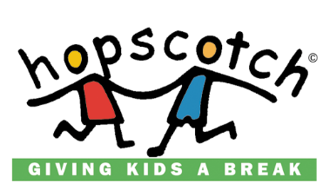
Name of Charity: HopScotch Children’s Charity. Charity No. SCO28660
Details of Donor

Title: Forename: Surname:

Address:

Post Code: Tel No:

Email: Mobile:

Declaration

By ticking the box I declare that I am a UK Taxpayer and would like HOPSCOTCH to treat all of my donations in the past, present and future until I notify otherwise, as Gift Aid donations. I confirm I have paid or will pay an amount of Income Tax and/or Capital Gains Tax for each year at least equal to the amount of tax that HOPSCOTCH will reclaim on my gifts for that tax year. I understand that HOPSCOTCH will reclaim 25p of tax on every £1 that I have given.

Notes

- Please notify HOPSCOTCH if you change your name and address whilst the declaration is in force.
- You may cancel the declaration at any time by notifying HOPSCOTCH.
- If in the future your circumstances change and you no longer pay income or capital gains tax equal to the tax HOPSCOTCH reclaims you should cancel your declaration or you may incur an additional liability to tax.
- If you pay tax at a higher rate you can claim relief in your Self-Assessment Tax Return.
- If you are unsure whether you qualify for Gift Aid tax relief or not, please contact HOPSCOTCH on 0131 336 5554 or your local tax office and ask for leaflet IR113 Gift Aid.
Thanks for your kind donation.

Good childhood memories last a lifetime
Please note: For us to be able your process your Gift Aid claim, we need to keep these details on file. In line with the Data Protection Act we need to ask your permission to be able to do this.
If you do not wish for these details to be kept on file, please tick here

